# **Email Configuration:**

Go to Manage Jenkins and click on configure systems.

At extreme end will see E-mail Notification and fill the details

Default SMTP sever: smtp.gmail.com

Default user email suffix: if it is Gmail give @gmail.com or if it is yahoo give @yahoo.com

Click Use SMTP Authentication

Username: give you mail id

Password: give your mail id passwd

Click SSL

SMTP port: 465

Click on test connection

Give any gmail id and click test connection

if it gives Email was successfully sent your Email notification successfully completed.

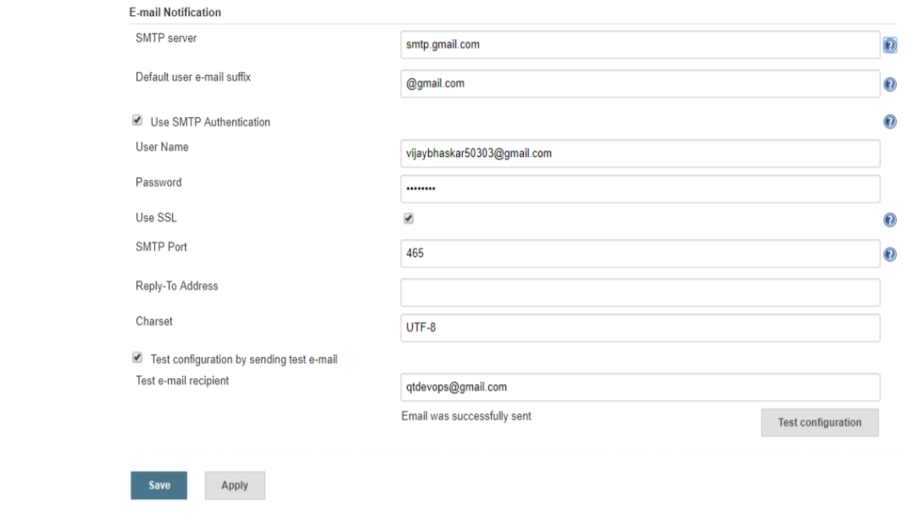

While configuring Email notation if you’re getting below error:

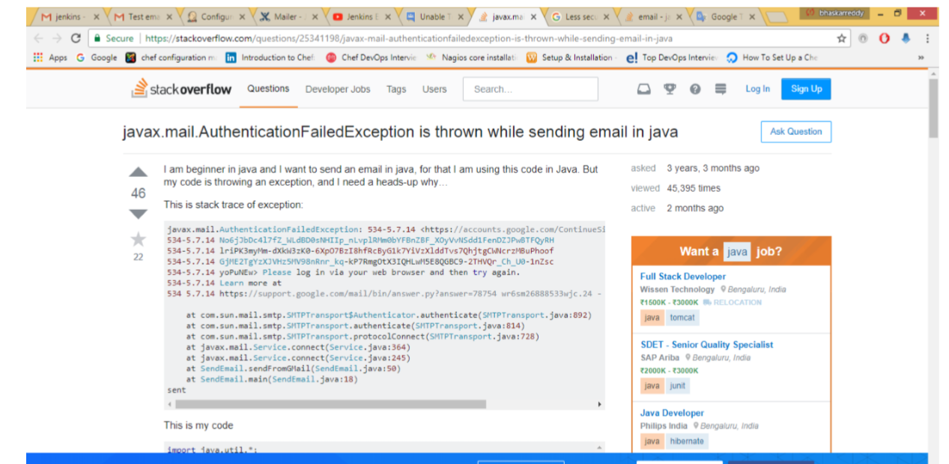

Click below link

<https://www.google.com/settings/security/lesssecureapps>

<https://myaccount.google.com/lesssecureapps>

You will see turn off or turn on. Click Turn on

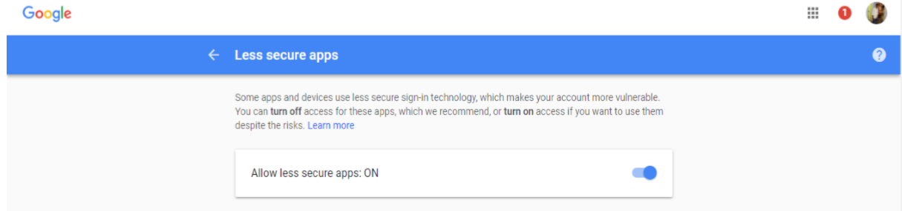

After Compilation Email notification. Go to Job configuration at post build action select Email notification give mail id whom you want send about your build status.

